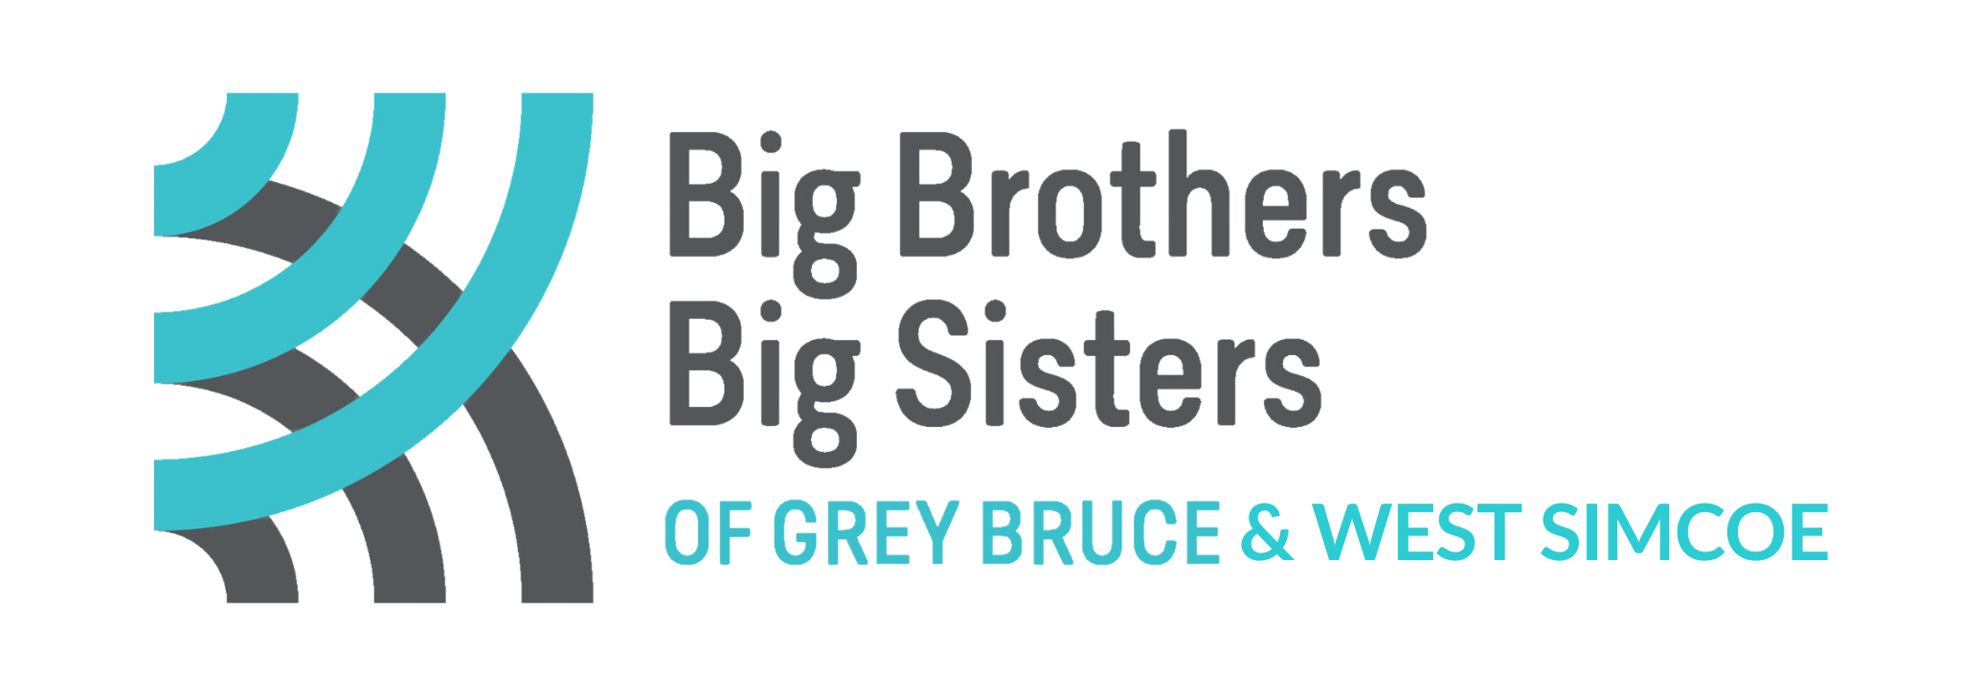

**THIRD PARTY FUNDRAISING AGREEMENT**

Thank you for your interest in hosting a third-party fundraiser in support of Big Brothers Big Sisters of Grey Bruce & West Simcoe (BBBSBGWS). BBBSGBWS encourages third-party fundraising events that align with our mission, vision and values. All third-party events must be approved by BBBSGBWS’ Executive Director prior to holding the event. Approval is based on the type, theme and financial viability of the event.

The signing of this agreement indicates BBBSGBWS’ approval of a request to hold a third-party event and the event organizer’s understanding of the following procedures and expectations.

1. BBBSGBWS reserves the right to withhold the use of its name and logo from any event, initiative, promotion, performance or presentation that seems inappropriate, or doesn’t align with our mission, vision and values.
2. Any organization/group wishing to use the BBBSGBWS name or logo on any materials, including advertising, must receive prior approval from our organization.
3. All promotional materials must state that your event is “in support” of BBBSGBWS and is not an official BBBSGBWS event.
4. Taking commission, for any purpose, on funds raised as part of a third-party event is strictly prohibited.
5. The event organizer is responsible for meeting all municipal/provincial/federal standards and fulfill all legal authorization(s), permit(s), license(s), precaution(s) and/or general liability insurance required to organize the event, unless otherwise agreed. BBBSGBWS must not be party to any liability coverage without prior knowledge and/or approval. BBBSGBWS accepts no legal responsibility and cannot be held liable for any risk, injury or otherwise.
6. BBBSGBWS agrees to provide the event organizer/group with appropriate recognition, endorsement and advertising.
7. The event organizer will be responsible for all costs related to the event and will handle all monies until the official donation is submitted to BBBSGBWS, unless otherwise agreed. Event expenses are to be deducted before sending proceeds to BBBSGBWS. BBBSGBWS shall incur no costs unless otherwise agreed in writing prior to the event or promotion.
8. The event organizer/group agrees to handle all monetary transactions for the special event or promotion and agrees to present the proceeds to BBBSGBWS as agreed in writing with BBBSGBWS.
9. When tax receipts are requested, the event organizer is responsible for collecting the names, addresses and contact information of all donors, and is required to send the appropriate materials to BBBSGBWS.
10. BBBSGBWS official income tax receipts in accordance with Canada Revenue Agency guidelines. **Charitable Registration Number:** **106793797RR0001**
11. BBBSGBWS will make every effort to provide BBBSGBWS representation at the event, but it is at the agency’s discretion and will be based on availability, location, and nature of the event, and must be determined prior to the event date.
12. The event organizer agrees to ensure that all materials borrowed are returned and in the same condition they were received. The event organizer agrees to accept responsibility for damage or loss of materials borrowed from BBBSGBWS.
13. BBBSGBWS will not be responsible for mailing materials to attendees/participants or volunteers, other than the mailing of applicable tax receipts.
14. The event organizer must send a complete accounting of all income and expenses associated with the event. By publicly naming BBBSGBWS as the beneficiary of your initiative, you are agreeing to donate the net proceeds (or percentage agreed upon) to BBBSGBWS after the event is completed.

**Please send a cheque made payable to:**

Big Brothers Big Sisters of Grey Bruce

Attn: Beth Aubrey

1793 3rd Ave W, Owen Sound ON N4K 6Y2

This agreement has been reviewed and agreed upon by:

Third Party Fundraising – Group Name:

______________________________________________________________________

|  |  |
| --- | --- |
| _________________________________ | _________________________________ |
| Signature – Event Organizer | Signature – BBBSGBWS |
|  |  |
| _________________________________ | _________________________________ |
| Date | Date |